US slaps sanctions on ex-army chief Aziz, family



“Crimes committed in Gaza must be prosecuted at the highest level, regardless of the perpetrators.”

**SECOND EDITION**



Regd. No. DA 781

Vol. XXXIV No. 122

Jaishtha 8, 1431 BS

Zilqad 13, 1445 Hijri

16 Pages : Tk 15.00

## Cites ‘involvement in significant corruption’

DHAKA WEDNESDAY JUNE 06, 2024

STAFF CORRESPONDENT

The US yesterday imposed sanctions on former Bangladesh army chief General (retd) Aziz Ahmed and his immediate family members for what it said was his involvement in

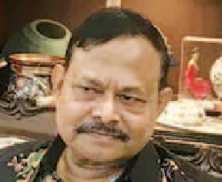

**ALLEGATIONS**

Undermining Bangladesh’s democratic

institutions

Interfering in public processes to help his brother evade accountability for crime committed

Working with his brother to ensure improper awarding of military contracts

significant corruption. “This action [imposing

sanctions] renders Aziz and his immediate family members generally ineligible for entry into the United States,” read a press statement of the US State Department.

It said the actions of Aziz contributed to the undermining of Bangladesh’s democratic institutions and the public’s faith in public institutions and processes.

“Aziz Ahmed engaged in significant corruption

by interfering in

Foreign Operations, and Related Programs Appropriations Act.

A public designation refers to identification and notification regarding individuals complicit in significant corruption or gross violations of human

rights.

The press statement said this designation reaffirms the US

commitment to s t r e n g t h e n i n g democratic institutions and the rule of law in Bangladesh.

“The United States supports anti- corruption efforts in Bangladesh through assistance to make government services more transparent and affordable, improve the business and regulatory environment, and build capacity in investigating

and prosecuting money

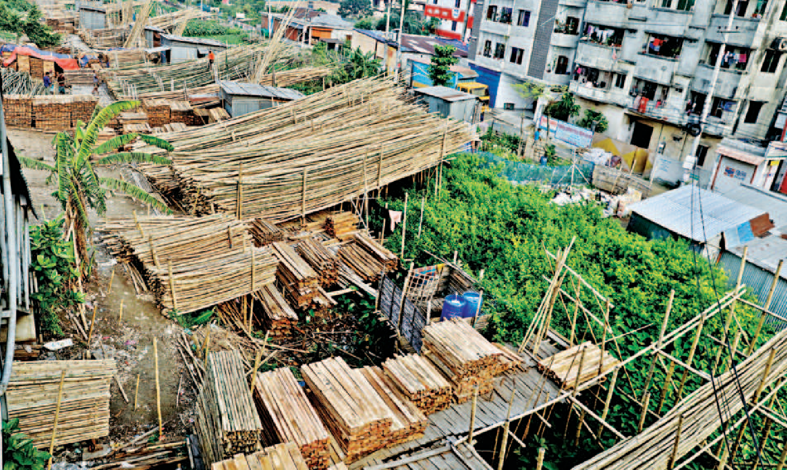PHOTO: **ANISUR RAHMAN**

**WHERE’S THE CANAL? … Believe it or not, this is a part of the DND Canal that flows from Jatrabari to Kanchpur. Over the past decade, illegal structures and bamboo and timber trades, among others, have eaten up long stretches of the waterbody. Various initiatives by the Water Development Board to stop the encroachments have fallen flat. The photo was taken in Narayanganj’s Signboard area a few days ago.**

public processes while helping his brother evade accountability for criminal activity in Bangladesh.

“Aziz also worked closely with his brother to ensure the improper awarding of military contracts and accepted

bribes in exchange for government

corruption.

laundering and other financial crimes.”

The sanctions came just days after the visit of US Assistant Secretary of State for South and Central Asia Donald Lu, who had spoken about supporting Bangladesh in its fight against

Fixed expenses to eat up

40pc of next budget

REJAUL KARIM BYRON

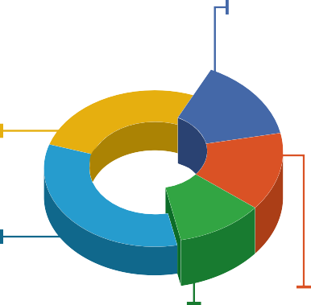

**2024-25 BUDGET PLAN**

TK **7,96,900**CR

*Where to spend*

**27**%

Others

**15**%

Interest

Payment

**KEY POINTS**

**33**%

ADP

SOURCE: FINANCE MINISTRY

**11**% **14**%

Subsidies

Pay and and Allowance Incentives

The government plans to spend 40% of budget on subsidies,

interest payments, and salaries and allowances

Over the last five years, spending in these three areas increased faster than revenue earnings

Spending on social protection will be limited

The government has to spend about

# Plot thickens over AL MP Azim going

missing

RASHIDUL HASAN *and*

MOHAMMAD JAMIL KHAN

appointments for his personal benefit.”

US State Department Spokesperson Matthew Miller announced the public designations made under Section 7031(c) of the annual Department of State,

Speaking to the media at his home in the capital yesterday, Aziz said, “I am surprised.” Refuting the allegations, he said the move could have been made to embarrass

SEE PAGE 2 COL 5

40 percent of the next budget

on subsidies, interest payments, and salaries and allowances of government employees, which will limit its ability to spend on social safety net, health and education.

According to a finance ministry plan, the government may allocate

Intelligence a g e n c i e s fear the

worst for A w a m i League MP A n w a r u l Azim Anar



**Anwarul Azim**

They needed to

sanction someone and picked me

## Aziz tells

SHAHEEN MOLLAH *and* ARAFAT RAHAMAN

Former army chief Gen (retd) Aziz Ahmed yesterday rejected the allegations the US authorities made while imposing sanctions against him and his immediate family members.

“I am surprised. Why am I being sanctioned almost three years after retirement? I’m not involved in any kind of politics and business,” he told The Daily Star in an interview last night, hours after the US state department announced the sanctions.

The US state department in a release said Aziz’s actions contributed to the undermining of Bangladesh’s democratic institutions and the people’s faith in public institutions and processes; he engaged in significant corruption by interfering in public processes to help his brother evade accountability for criminal activity; he worked closely with his brother to ensure the improper awarding of military contracts; and he accepted bribes in exchange for government appointments for his personal benefit.

‘Political

equations’ could be at play

Believe AL leaders

PARTHA PRATIM BHATTACHARJEE

A section of top Awami League leaders think there might be some “political equations” behind the US sanctions on former army chief Aziz Ahmed and his immediate family members.

They also expressed concern that similar measures might be on the way for some other incumbent and former officials.

Some leaders believe the latest sanctions indicate that the US stance toward the AL government has not changed much since the

Tk 3,14,700 crore for the three

sectors from the total budget of Tk 7,96,900 crore in fiscal 2024-

2025.

Of the allocation, Tk 1,16,000 crore will be spent on interest payments, Tk 1,11,000 crore on subsidies and incentives, and Tk 87,700 crore for paying government employees.

Over the last five years, expenditures on wages, pensions, subsidies, and interest increased faster than the revenue earnings, narrowing the government’s fiscal space.

Ahsan H Mansur, executive director of the Policy Research Institute of Bangladesh, said, “If the non-discretionary expenditures eat up most of the budget allocation, then not much is left.”

He said they had predicted a sharp rise in expenditures on wages, subsidies, and interest five to seven years ago.

“It took about 10 years for the government to fall into this pit, and it would take another 10 years to get out of it.”

However, the country needs to address the problem and for this, a reform initiative is needed, he added.

He suggested bringing down domestic borrowings, subsidies and other unnecessary expenditures, and increasing revenue.

Finance ministry officials

said the government was unable to increase allocation for safety net programmes, healthcare, and education due to resource constraints though it intended to spend more in those sectors.

The government spending on interest payments, both foreign and domestic, has been increasing every year.

Interest payment rates have risen in recent years, and the finance

SEE PAGE 2 COL 2

who has gone missing in India, said a source in a local law enforcement agency.

“An Indian security agency has collected the details of four suspects. It also detained one for interrogation,” the source told The Daily Star.

Contacted, officials at the Bangladesh High Commission in New Delhi and the Deputy High Commission in Kolkata yesterday said they were yet to receive any official confirmation from the Indian government about the Jhenaidah-4 lawmaker’s status and whereabouts.

Speaking to this newspaper last night, Home Minister Asaduzzaman Khan said, “We are hopeful we will be able to solve the

SEE PAGE 2 COL 5

SEE PAGE 2 COL 2 SEE PAGE 6 COL 1

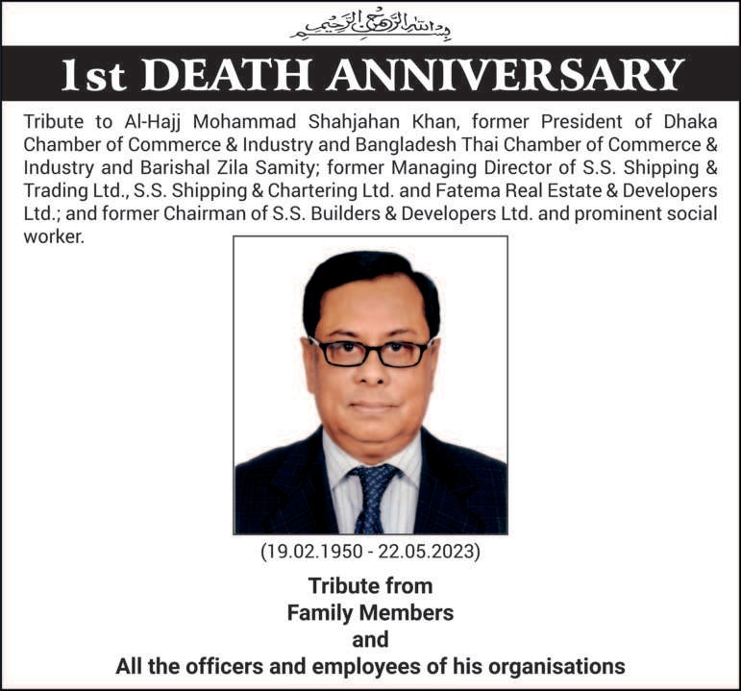

wishes its valued readers, patrons, well-wishers and advertisers on



**BUDDHA PURNIMA**

# Buddha Purnima today

AGENCIES

Buddha Purnima, the biggest religious festival of the Buddhist community, will be celebrated across the country today.

Buddha Purnima marks the birth, enlightenment and death of Gautama Buddha. On this day in

563 BC, Buddha was born as Siddhartha

SEE PAGE 2 COL 1